Superior University Gold Campus
Arificial Intelligence Lab
lab 1
Name: Tasawar Hussain
Roll no: SU92-BSSEM-F24-073
1> Objective:
The objective of this lab is to understand fundamental AI decision-making paradigms specifically comparing Rule Based AI with Probability Based AI models. Furthermore, it covers building a deterministic, rule-based evaluation logic in Python to test student eligibility against defined conditions.
2> Code Implementation Summary :
Task 1 (lab1_compare.py):
Demonstrates the core difference between deterministic rule checking (e.g., score &gt;= 70 and documents complete) and a probabilistic threshold model(e.g., probability score &gt;= 0.70).
Task 2 (lab1_rules.py):
Implements a multi-conditional rule-based function check_student() that evaluates eligibility based on four parameters:
• Score must be at least 70
• Documents must be complete (True)
• Attendance must be at least 75%
• Age must be at least 18
Task 3 (README.md):
Contains repository documentation, project objectives, description of scripts, running instructions, and rule criteria.
3> Test Cases &amp; Results :
Test Case | Score | Docs Complete | Attendance (%) | Age | Result
Case 1 | 80 | True | 80% | 18 | Review
Case 2 | 80 | True | 60% | 18 | Hold (Attendance < 75%)
Case 3 | 80 | True | 80% | 16 | Hold (Age < 18)
Case 4 | 70 | True | 75% | 18 | Review

4> Execution Screenshots :
A
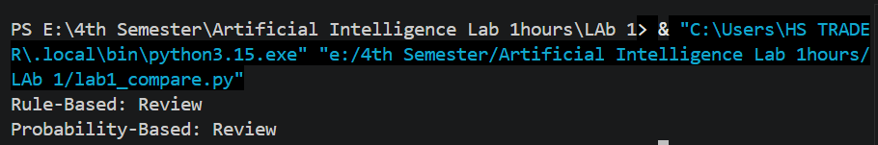
B
